Question 3)

According to the decision-theoretic recommendation, 148.8 dollars are expected to be earned.

Question 6)

If I use emotional response to calculate payout, 77.72 dollars are expected to be earned. If I use expected utility to calculate the payout, the expected amount of money to be earned, the value is 142.4 dollars.

Question 7)

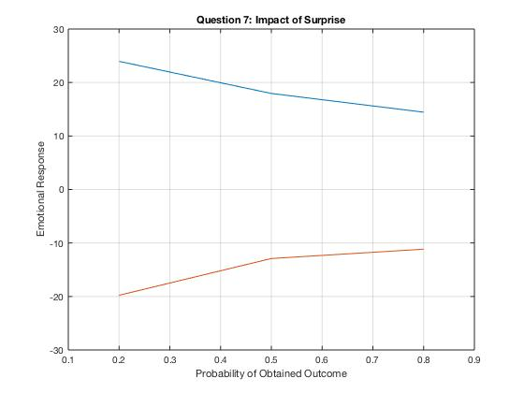

Matlab Code:

X1 = [0.2 0.5 0.8];

Y1 = [23.953125 17.95049505 14.44954128];

plot(X1,Y1);

grid on;

hold on;

X2 = [0.2 0.5 0.8];

Y2 = [-19.7761194 -12.90526316 -11.15966387];

plot(X2,Y2);

axis([0.1 0.9 -30 30]);

title('Question 7: Impact of Surprise');

xlabel('Probability of Obtained Outcome');

ylabel('Emotional Response');

hold off;

Question 8)

My evidence of surprise results are consistent with the predictions of Decision Affect Theory. Even though my values are different, they seem to follow the same pattern as DAT.

Question 9)

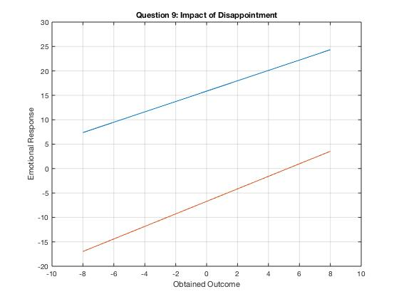

Matlab Code:

X1 = [-8 8];

Y1 = [7.37037037 24.3417722];

plot(X1,Y1);

grid on;

hold on;

X2 = [-8 8];

Y2 = [-16.968992 3.54237288];

plot(X2,Y2);

axis([-10 10 -20 30]);

title('Question 9: Impact of Disappointment');

xlabel('Obtained Outcome');

ylabel('Emotional Response');

hold off;

Question 10)

My evidence of disappointment results are consistent with the predictions of Decision Affect Theory. I have the same situation as question 8 because my values are different, but they follow the same pattern as the graph given in the homework description.

Question 11)

* EU_pick: F1 score is 0.377 and Accuracy is 0.786.
* DAT_pick: F1 score is 0.323 and Accuracy is 0.827.

The F1 score is slightly higher in the EU_pick by a factor of 0.054. However, the Accuracy is slightly higher in the DAT_pick by a factor of 0.041. To my perception, both models are equally accurate. In conclusion, both models could be used to make a good decision on choosing a gamble.